**Creating VPC**

Step 1: Click on services an search for VPC

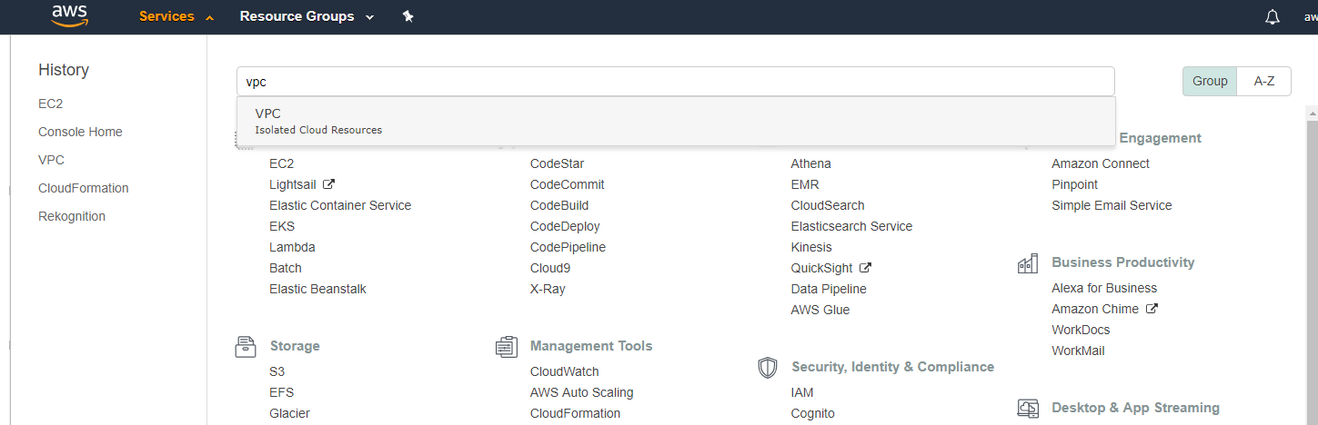

Step 2: Click on “Create VPC”

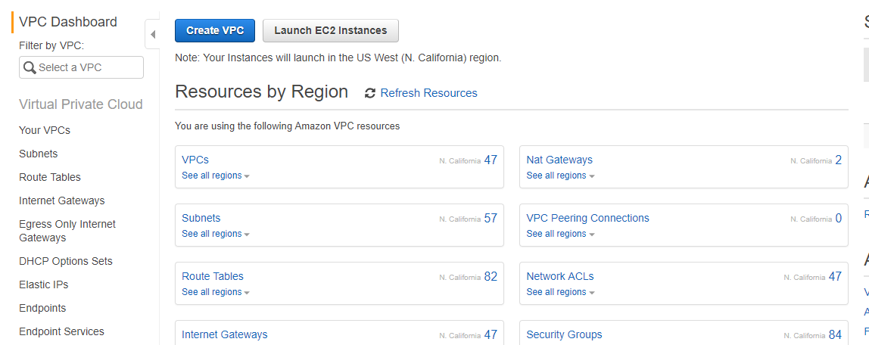

Step 3: Fill out all the required forms

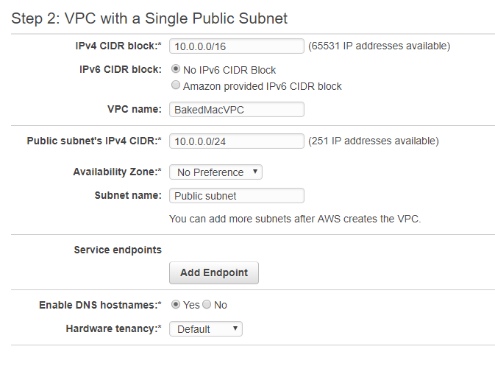

Step 4: Click on “Yes, Create”

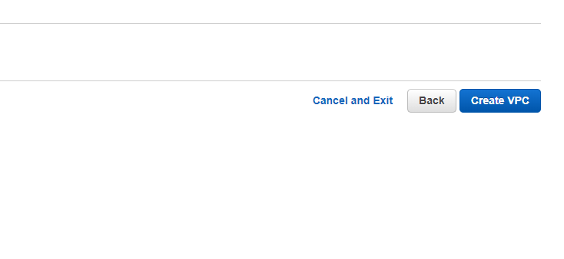

**Creating Stack**

Step 1: Click on services and search for Cloud Formation

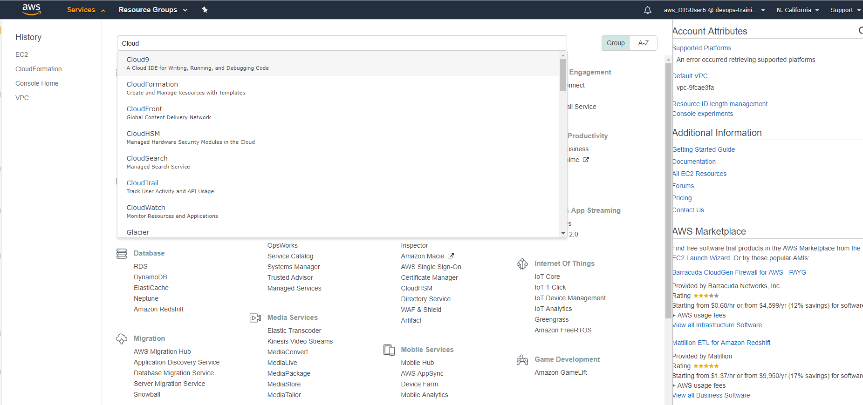

Step 2: Click on “create stack”

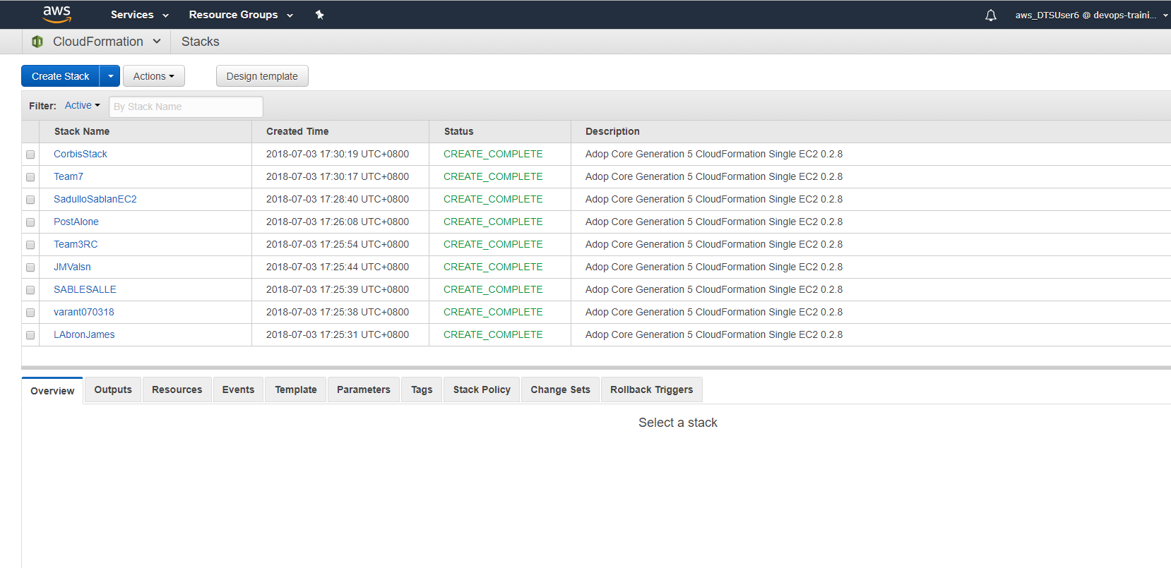

Step 3: Upload the json template

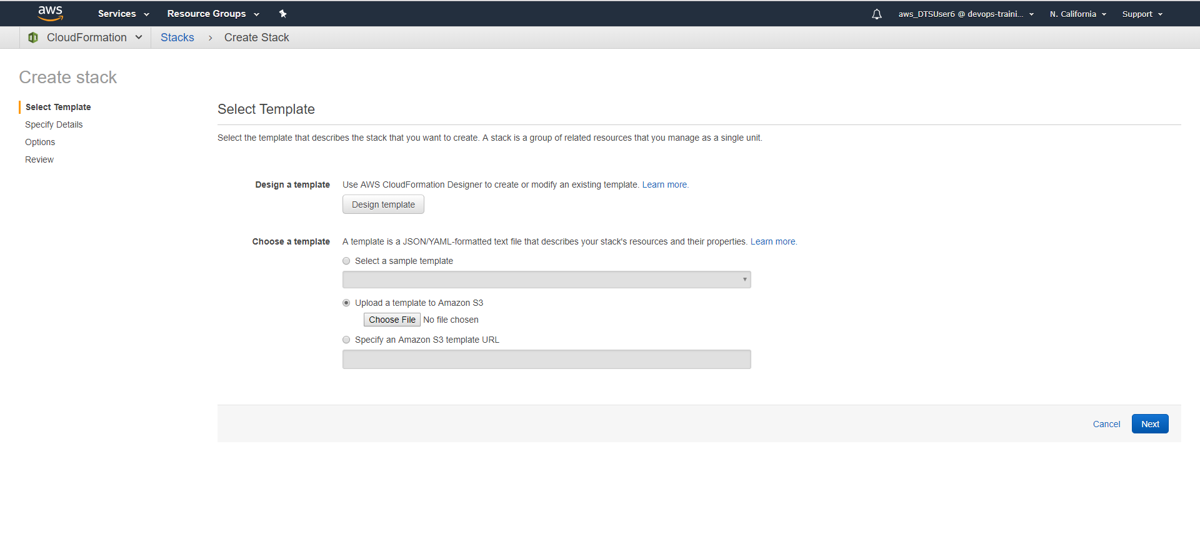

Step 4: Choose the json the template you want to use

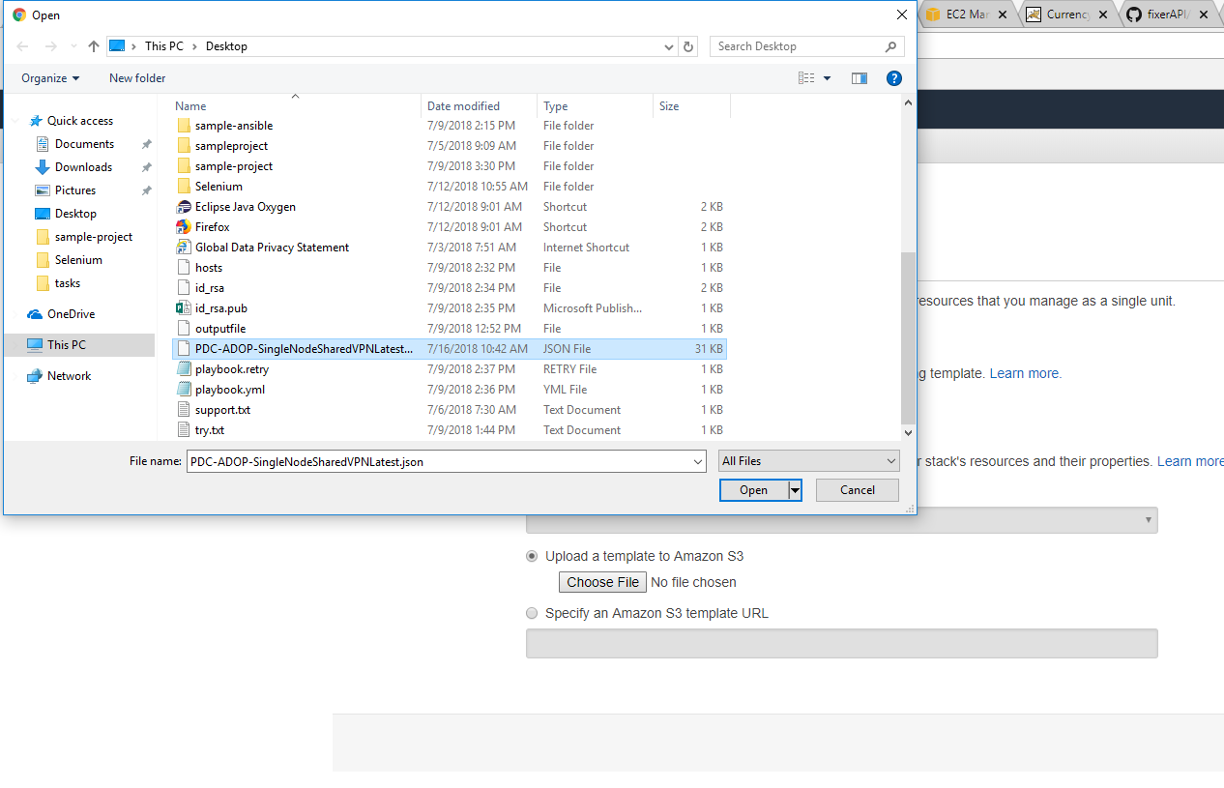

Step 5: Click next to proceed to the next step



Step 6: Fill out the forms with the correct information of your vpc

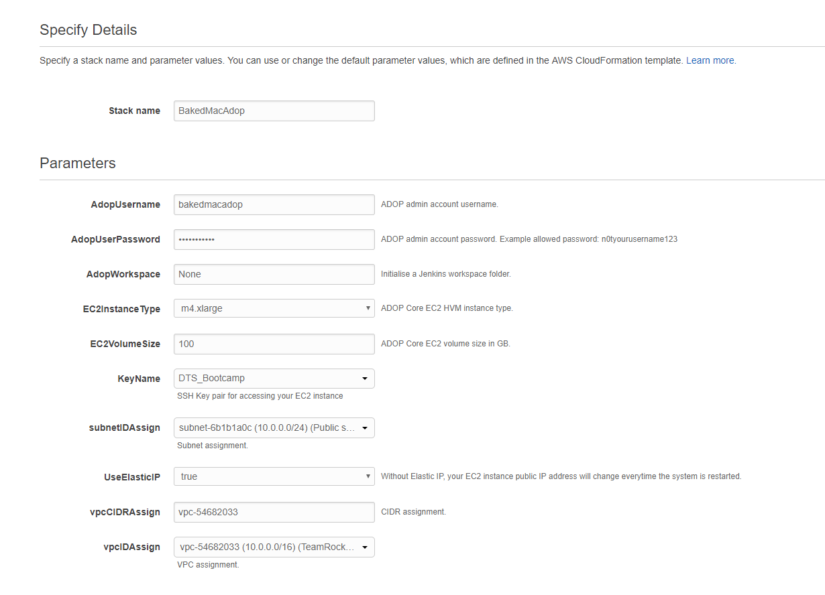

Step 7: Click on Next

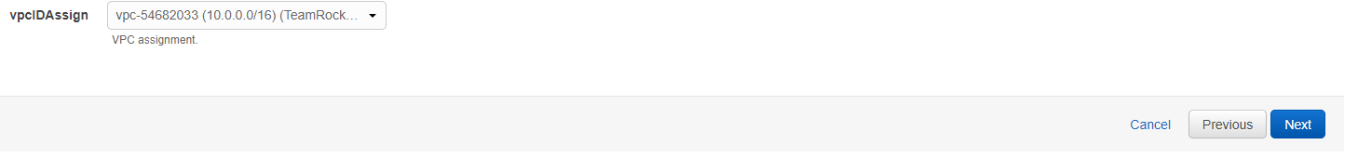

Step 8: Fill out the following forms with Name as key and the stack name as the value

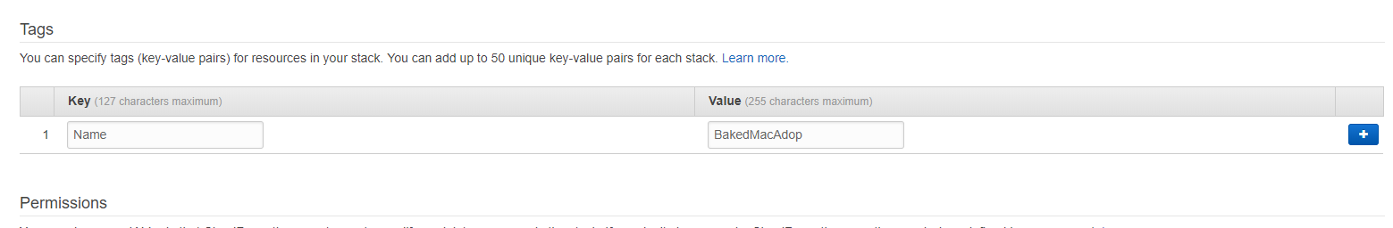

Step 9: Click on Next

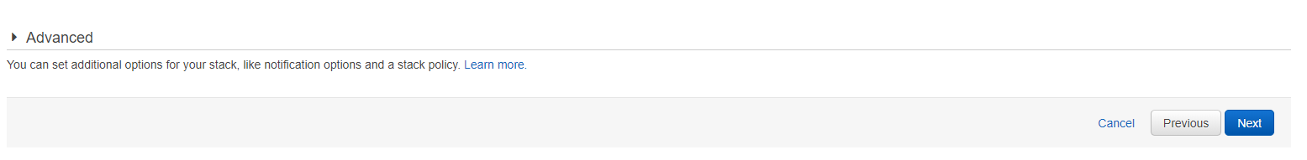Step 10: Click on create to create stack

